**TRUN OFF THE FIREWALL AND THE ANTI-VIRUS**

**Help File**

Follow these instructions before the project execution. These steps are to change the DriveHQ account and to Change the Email.

**For Drive HQ:**

1) First create your own account in driveHQ

<https://www.drivehq.com/secure/FreeSignup.aspx>

Then login into the drive hq and create 3 folders cloud1, cloud2, cloud 3.

2) Then go to the source code location: **“\src\java\Networks”**

There you can see “DRIVE_Network.java” file. Open it in any Editor and see the line number: 31

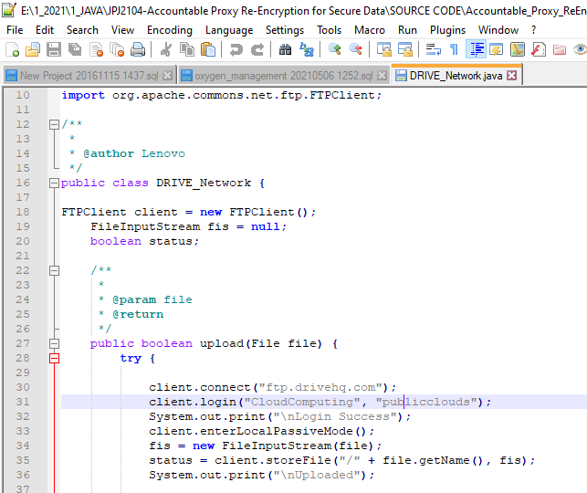

In this screenshot: “**CloudComputing**” is the username and “**publicclouds**” is the password. There just replace your account details and save it and then run the project again in the netbeans, so your files will be uploaded in your cloud account.

**For Email:**

1) First create your own email in Gmail for this project purpose. Important thing is the email should not have 2 Factor authentication. So **first turn off the 2 factor authentication in the Gmail account** which you have created.

2) Now go to the source code location “\src\java\Networks”

Where you can find the file “Mail.java”.

Open it in any editor. Go the line number: 35

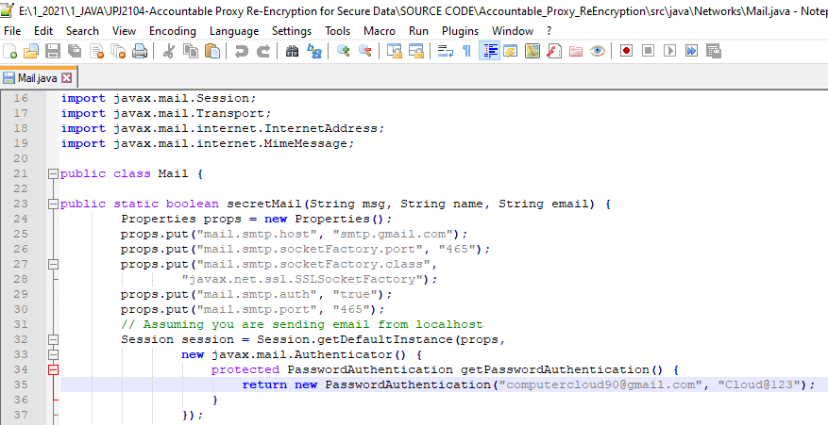

In the screenshot you can check the line number 35 which has **computercloud90@gmail.com** which is the email id and “**Cloud@123**” is the password. Now you just replace your accounts with password and save it and then run the project in the netbeans, so now you will receive the email from the account that you created and note **that turn off the antivirus and firewall and have fast internet connection.**